PROBLEMS

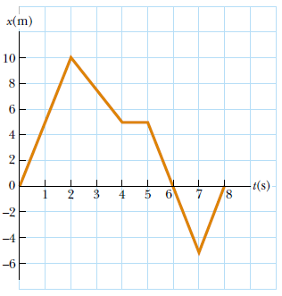
Example-1: The position versus time for a certain particle moving along the x axis is shown in Figure. Find the average velocity in the time intervals (a) 0 to 2 s, (b) 0 to 4 s, (c) 2 s to 4 s, (d) 4 s to 7 s, (e) 0 to 8 s.

Example-2: The Find the instantaneous velocity of the particle described in Figure at the following times: (a) t =1.0 s, (b) t = 3.0 s, (c) t = 4.5 s, and (d) t = 7.5 s.

Example-3: A particle moves according to the equation x = 10t 2 where x is in meters and t is in seconds. (a) Find the average velocity for the time interval from 2.00 s to 3.00 s. (b) Find the average velocity for the time interval from 2.00 to 2.10 s.

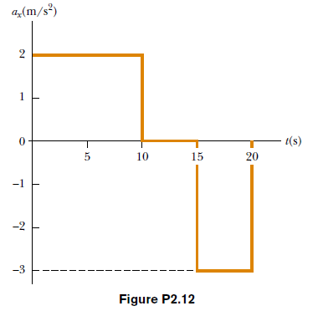
Example-4: A particle starts from rest and accelerates as shown in Figure P2.12. Determine (a) the particle’s speed at t =10.0 s and at t = 20.0 s, and (b) the distance traveled in the first 20.0 s.

Example-5: An object moves along the x axis according to the equation x(t) = (3.00t2 - 2.00t +3.00) m. Determine (a) the average speed between t =2.00 s and t=3.00 s, (b) the instantaneous speed at t ! 2.00 s and at t ! 3.00 s, (c) the average acceleration between t ! 2.00 s and t ! 3.00 s, and (d) the instantaneous acceleration at t ! 2.00 s and t=3.00 s.

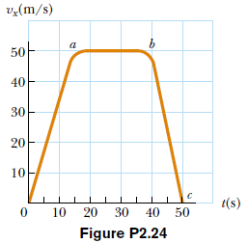
Example-6: Figure P2.24 represents part of the performance data of a car owned by a proud physics student. (a) Calculate from the graph the total distance traveled. (b) What distance does the car travel between the times t =10 s and t = 40 s? (c) Draw a graph of its acceleration versus time between t = 0 and t = 50 s. (d) Write an equation for x as a function of time for each phase of the motion, represented by (i) 0a, (ii) ab, (iii) bc. (e) What is the average velocity of the car between t =0 and t=50 s?

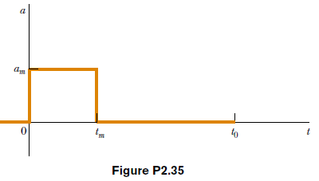
Example-7: Within a complex machine such as a robotic assembly line, suppose that one particular part glides along a straight track. A control system measures the average velocity of the part during each successive interval of time $∆t_{0}=t_{0}-0$compares it with the value vc it should be, and switches a servo motor on and off to give the part a correcting pulse of acceleration. The pulse consists of a constant acceleration am applied for time interval $∆t_{m}=t_{m}-0$within the next control time interval $∆t_{0}$. As shown in Fig. P2.35, the part may be modeled as having zero acceleration when the motor is off (between tm and t0). A computer in the control system chooses the size of the acceleration so that the final velocity of the part will have the correct value vc . Assume the part is initially at rest and is to have instantaneous velocity vc at time t0. (a) Find the required value of am in terms of vc and tm. (b) Show that the displacement Δx of the part
during the time interval Δt0 is given by Δx=vc (t0-0.5tm). For specified values of vc and t0, (c) what is the minimum displacement of the part? (d) What is the maximum displacement of the part? (e) Are both the minimum and maximum displacements physically attainable?

Example-8: A golf ball is released from rest from the top of a very tall building. Neglecting air resistance, calculate (a) the position and (b) the velocity of the ball after 1.00, 2.00, and 3.00 s.

Example-9: In Mostar, Bosnia, the ultimate test of a young man’s courage once was to jump off a 400-year-old bridge (now destroyed) into the River Neretva, 23.0 m below the bridge. (a) How long did the jump last? (b) How fast was the diver traveling upon impact with the water? (c) If the
speed of sound in air is 340 m/s, how long after the diver took off did a spectator on the bridge hear the splash?

Example-10: A ball is dropped from rest from a height h above the ground. Another ball is thrown vertically upwards from the ground at the instant the first ball is released. Determine the speed of the second ball if the two balls are to meet at a height h/2 above the ground.

Example-11: A woman is reported to have fallen 144 ft from the 17th floor of a building, landing on a metal ventilator box,which she crushed to a depth of 18.0 in. She suffered only minor injuries. Neglecting air resistance, calculate (a) the speed of the woman just before she collided with the ventilator, (b) her average acceleration while in contact with the box, and (c) the time it took to crush the box.

Example-12: The height of a helicopter above the ground is given by h = 3.00t^3, where h is in meters and t is in seconds. After 2.00 s, the helicopter releases a small mailbag. How long after its release does the mailbag reach the ground?

Example-13: The speed of a bullet as it travels down the barrel of a rifle toward the opening is given by v =$(5.00 {10}^{7} t^{2}+3.00 {10}^{5}t$, where v is in meters per second and t is in seconds. The acceleration of the bullet just as it leaves the barrel is zero. (a) Determine the acceleration and position of the bullet as a function of time when the bullet is in the barrel. (b) Determine the length of time the bullet is accelerated. (c) Find the speed at which the bullet leaves the barrel. (d) What is the length of the barrel?

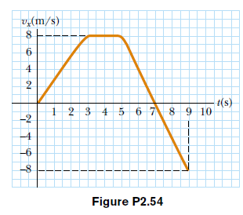
Example-14: A student drives a moped along a straight road as described by the velocity-versus-time graph in Figure P2.54. Sketch this graph in the middle of a sheet of graph paper. (a) Directly above your graph, sketch a graph of the position versus time, aligning the time coordinates of the two graphs. (b) Sketch a graph of the acceleration versus time directly below the vx-t graph, again aligning the time coordinates. On each graph, show the numerical values of x and ax for all points of inflection. (c) What is the acceleration at t= 6 s? (d) Find the position (relative to the starting point) at t = 6 s. (e) What is the moped’s final position at t = 9 s?

Example-15: A motorist drives along a straight road at a constant speed of 15.0 m/s. Just as she passes a parked motorcycle police officer, the officer starts to accelerate at 2.00 m/s2 to overtake
her. Assuming the officer maintains this acceleration, (a) determine the time it takes the police officer to reach the motorist. Find (b) the speed and (c) the total displacement of the officer as he overtakes the motorist.

Example-16: If the polar coordinates of the point (x, y) are (r, Θ), determine the polar coordinates for the points: (a) (-x, y ), (b) (-2x, -2y), and (c) (3x, -3y).

