PROBLEMS

Example-1: In the Bohr model of the hydrogen atom, the speed of the electron is approximately 2.20x10⁶ m/s. Find (a) the force acting on the electron as it revolves in a circular orbit of radius 0.530x10⁻¹⁰ m and (b) the centripetal acceleration of the electron.

Example-2: A coin placed 30.0 cm from the center of a rotating, horizontal turntable slips when its speed is 50.0 cm/s. (a) What force causes the centripetal acceleration when the coin is stationary relative to the turntable? (b) What is the coefficient of static friction between coin and turntable?

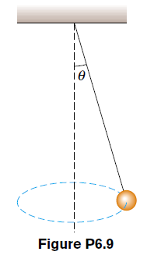
Example-3 : Consider a conical pendulum with an 80.0-kg bob on a 10.0-m wire making an angle of 5.00° with the vertical (Fig. P6.9). Determine (a) the horizontal and vertical components of the force exerted by the wire on the pendulum and (b) the radial acceleration of the bob.

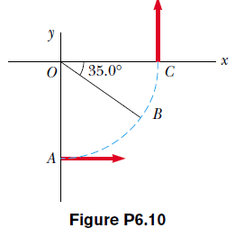
Example-4 : A car initially traveling eastward turns north by traveling in a circular path at uniform speed as in Figure P6.10. The length of the arc ABC is 235 m, and the car completes the turn in 36.0 s. (a) What is the acceleration when the car is at B located at an angle of 35.0°? Express your answer in terms of the unit vectors ˆi and ˆ j. Determine (b) the car’s average speed and (c) its average acceleration during the 36.0-s interval.

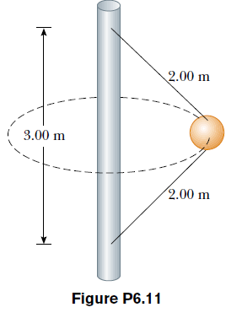
Example-5 : A 4.00-kg object is attached to a vertical rod by two strings, as in Figure P6.11. The object rotates in a horizontal circle at constant speed 6.00 m/s. Find the tension in (a) the upper string and (b) the lower string.

Example-6 : A 40.0-kg child swings in a swing supported by two chains, each 3.00 m long. If the tension in each chain at the lowest point is 350 N, find (a) the child’s speed at the lowest point and (b) the force exerted by the seat on the child at the lowest point. (Neglect the mass of the seat.)

Example-7 : A hawk flies in a horizontal arc of radius 12.0 m at a constant speed of 4.00 m/s. (a) Find its centripetal acceleration. (b) It continues to fly along the same horizontal arc but increases
its speed at the rate of 1.20 m/s2. Find the acceleration (magnitude and direction) under these conditions

Example-8 : A 0.400-kg object is swung in a vertical circular path on a string 0.500 m long. If its speed is 4.00 m/s at the top of the circle, what is the tension in the string there?

Example-9 : A roller coaster car (Fig. P6.19) has a mass of 500 kg when fully loaded with passengers. (a) If the vehicle has a speed of 20.0 m/s at point !, what is the force exerted by the track on the car at this point? (b) What is the maximum speed the vehicle can have at " and still remain on the track?
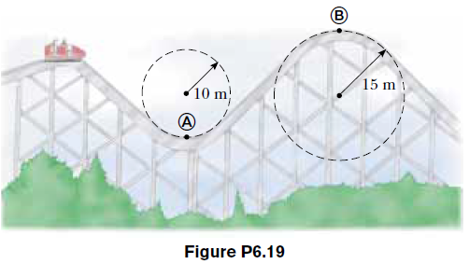

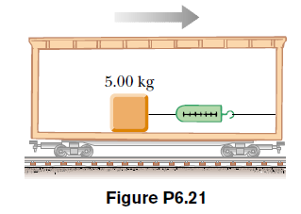
Example-10 : An object of mass 5.00 kg, attached to a spring scale, rests on a frictionless, horizontal surface as in Figure P6.21. The spring scale, attached to the front end of a boxcar, has a constant reading of 18.0 N when the car is in motion. (a) If the spring scale reads zero when the car is at rest, determine the acceleration of the car. (b) What constant reading will the spring scale show if the car moves with constant velocity? (c) Describe the forces on the object as observed by someone in the car and by someone at rest outside the car.

Example-11 : A small block is at rest on the floor at the front of a railroad boxcar that has length !. The coefficient of kinetic friction between the floor of the car and the block is µ_{k}. The car, originally at rest, begins to move with acceleration a. The block slides back horizontally until it hits the back wall of the car. At that moment, what is its speed (a) relative to the car? (b) relative to Earth?

